JAVA LAB 1 (4)

Write an Applet program inputs two integers from the user by using input dialog.

And using draw String to show the message below in JApplet.

If first number is **not Smaller** then the second one

Output “how the Java application program is executed by JVM”

If first number is **Smaller** then the second one

Output “how the Java applet program is executed by browser.”

Tip：

[showInputDialog](http://docs.oracle.com/javase/1.4.2/docs/api/javax/swing/JOptionPane.html#showInputDialog(java.awt.Component, java.lang.Object)) ([Component](http://docs.oracle.com/javase/1.4.2/docs/api/java/awt/Component.html) parentComponent, [Object](http://docs.oracle.com/javase/1.4.2/docs/api/java/lang/Object.html) message)

[drawString](http://docs.oracle.com/javase/6/docs/api/java/awt/Graphics.html#drawString(java.text.AttributedCharacterIterator, int, int)) ([AttributedCharacterIterator](http://docs.oracle.com/javase/6/docs/api/java/text/AttributedCharacterIterator.html" \o "interface in java.text) iterator, int x, int y)

Integer.parseInt (String s)

Graphics

import javax.swing.*;

import java.awt.*;

**Advanced:**

Please draw an image on the applet, and the image should be loaded from the file.

You should write it on the java code, not HTML.

Tip:

URL pic = new URL (getDocumentBase(), “images.jpg”);

Image image = ImageIO.read(pic);

Graphics

import java.net.URL;

import javax.imageio.ImageIO;

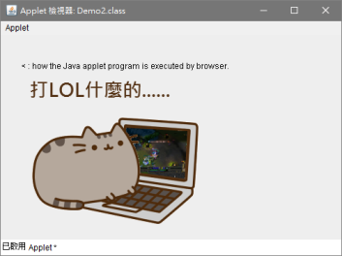<https://www.youtube.com/watch?v=tM1TVlHVdDs&feature=youtu.be>